2. The New England, Middle, and Southern Colonies

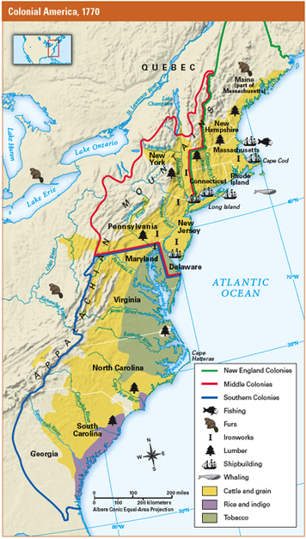
English settlers established colonies in North America for many reasons. Some colonies were set up by groups of businesspeople who hoped to profit from resources found in the Americas. Several colonies were settled by people looking for a place to practice their religion freely. One colony was established as a refuge for debtors (people who owe money), who would otherwise have been tossed into prison.
The English government supported all these efforts in part because it was competing for land in the Americas with such nations as France and Spain. England had another reason for establishing colonies: it was also competing for wealth. Like most western European nations in the late 1600s, England followed an economic policy that is called mercantilism. Under this policy, nations tried to gain wealth by controlling trade and establishing colonies. The colonies made money for England by supplying raw materials for its industries. England turned the raw materials into goods that it could sell to other nations and to its own colonies.
By 1733, there were 13 British colonies strung along the Atlantic coastline. They can be grouped into three distinct regions: the New England, Middle, and Southern Colonies. These regions had different climates and resources that encouraged settlers to develop different ways of life.

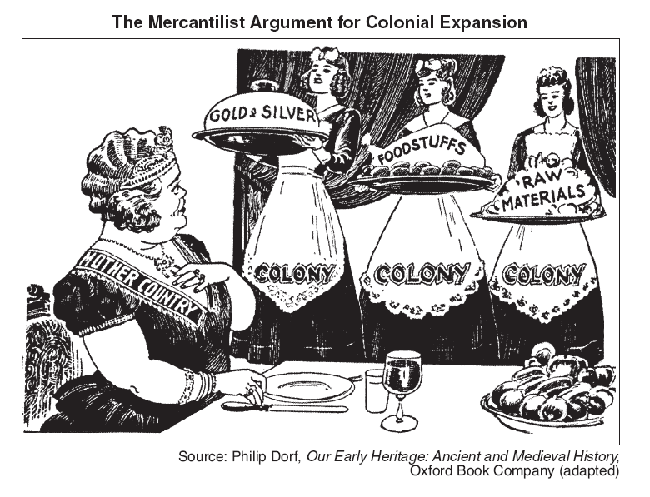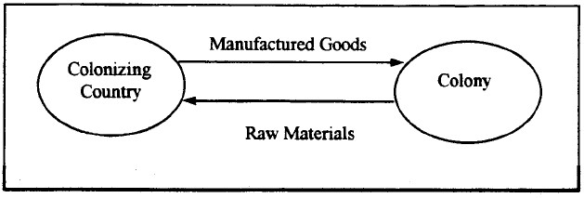
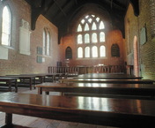
The New England Colonies The New England region included the colonies of Massachusetts, Rhode Island, Connecticut, and New Hampshire. As you will read, the first settlers of these colonies came to America seeking religious freedom.
In New England, farming was difficult because of the long, cold winters and the region’s rocky, hilly wilderness. But the forests and the sea provided useful resources and ways to make a living. New Englanders built their economy on small farms, lumbering, fishing, shipbuilding, and trade.
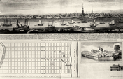The Middle Colonies The four Middle Colonies were New York, Pennsylvania, New Jersey, and Delaware. The landscape of this region ranged from the rich soil of coastal New Jersey and Delaware to the valleys and wooded mountains of New York and Pennsylvania. Farmers in the Middle Colonies raised a variety of crops and livestock. Lumbering, shipbuilding, and other occupations added to the many opportunities here.
The people who settled the Middle Colonies represented many cultures and religions. One important group, the Quakers, started the colony of Pennsylvania. Like the early settlers of New England, the Quakers were looking for freedom to practice their religion. Others seeking religious freedom soon followed. Settlements of French, Dutch, Germans, Swedes, Danes, Finns, Scots, Irish, and English spread throughout the Middle Colonies.

The Southern Colonies The five Southern Colonies were Maryland, Virginia, North Carolina, South Carolina, and Georgia. This region featured broad rivers and vast wetlands that gradually merged with the sea. The soil and the hot, wet climate were ideal for growing tobacco, rice, and other cash crops.
Wealthy colonists took advantage of these conditions by establishing large farms called plantations. Plantation owners relied on indentured servants and enslaved Africans to sow and harvest their fields. After being harvested, the crops could be brought by river to the coast and loaded on ships for transport to other colonies and to Europe.

Government in the Colonies All the colonies were settled with the permission of the king of England. For each colony, the king issued a charter, a formal document that outlined the colony’s geographic boundaries and specified how it would be governed. Because the colonies were so far from England, however, they needed to be able to make their own laws and keep peace and order.
The colonies developed different forms of government, depending on the settlement’s purpose. Most of the colonies were self-governing. Colonists elected members of their community to a general assembly, which made their laws.
Many colonies also had a governor appointed by the king. As the king’s representative, the governor could overrule the elected assembly. Some colonies also had councils, groups of men who represented the English businessmen involved in starting the colony.
In Massachusetts, religious colonists established a theocracy, a government whose leaders ruled in the name of God. In time, however, a system of town meetings evolved in which colonists voted for representatives to govern them.
In many ways, the colonies were more democratic than England. Still, not all colonists had a voice in the government. Usually, only free, white, landowning men were allowed to vote. In some colonies, voters also had to belong to the preferred church. Other colonists including women, servants, slaves, and skilled tradesmen who were not landowners had no voting rights.

3. Massachusetts: A New England Colony
In the early 1600s, religion was very important in England. The king ruled the official Church of England, also called the Anglican Church. However, not everyone agreed with the church practices.
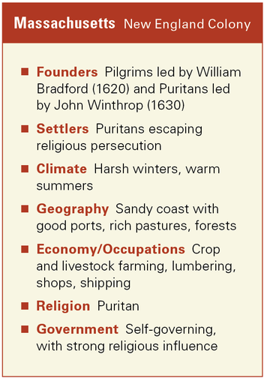
One group, who came to be called Puritans, wanted to “purify” the Anglican Church by making services simpler and doing away with ranks of authority. Another group, called Separatists, wanted to separate from the English church and form their own congregations. When the king began jailing Separatists for not attending Anglican services, some of them moved to Holland, where they could practice their religion freely.
But Holland wasn’t home, and the Separatists wanted their children to grow up in an English culture. In 1620, about 102 Separatists set sail for America aboard the Mayflower.The Separatists were called Pilgrims because they traveled for religious reasons. The Pilgrims hoped to build their idea of a perfect society in America. During their voyage, they signed an agreement called the Mayflower Compact that described the way they would govern themselves in the Americas.
After a long, uncomfortable journey across the Atlantic, the Pilgrims landed at Plymouth, near Cape Cod. Luckily for them, the local Indians welcomed them. Without the help of these American Indians, the Pilgrims might not have survived their first winter. The Indians taught them how to plant crops, trap animals, and catch fish. In 1621, the Pilgrims invited the Indians to share their first harvest in a three-day feast of thanksgiving. Americans still celebrate this holiday.
Ten years later, a large group of Puritans decided to follow the Pilgrims to America. The king was relieved to see them go and and sent them off with a charter for the colony of Massachusetts Bay. The charter said that the Massachusetts colonists would govern themselves. The Puritans were pleased with the charter because they wanted to build a community governed by the rules of the Bible. They hoped to set an example for the rest of the world. Their governor, John Winthrop, said, “We must consider that we shall be as a city upon a hill. The eyes of all people are upon us.”

4. Rhode Island: A New England Colony
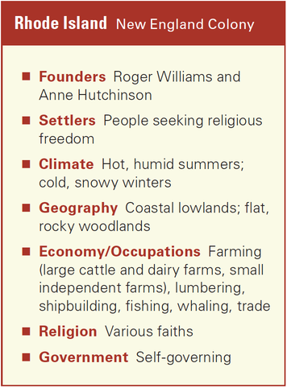
The Puritans of Massachusetts gained the freedom to practice their religion the way they wanted to. But instead of granting similar freedom to others, they set up a government that required everyone in the colony to worship as they did.

When a young minister named Roger Williams began preaching different ideas, the Puritans put him on trial. Williams believed that all people should be able to worship in any way they chose. “Forced worship,” he declared, “stinks in God’s nostrils.”
The Puritans ordered Williams sent back to England. Instead, on a cold winter day in 1636, he left his wife and children and fled south. After trudging through snow for days, he met a group of Indians near Narragansett Bay. The Indians cared for him until spring. When his family and a few followers joined him, Williams bought land from the Indians for a settlement. He called it Providence, a word meaning “the guidance and care of God.”
Williams welcomed people with different religious beliefs. Two years after he and his followers settled Providence, a colonist named Anne Hutchinson was also forced to leave Massachusetts for preaching against the Puritans. She and her family followed Williams and established a settlement called Portsmouth. In 1647, these and other settlements joined together to become the colony of Rhode Island. In 1663, Rhode Island elected an assembly to govern the colony.
The ideal of freedom in Rhode Island did not extend to enslaved Africans. Sea merchants soon discovered the riches that could be made in the slave trade. As a result, Rhode Island became one of the largest slave-trading centers in the world. Slave trading helped make the fortunes of some of the wealthiest families in New England. At the same time, the isolated coves along the Rhode Island coast provided perfect hiding places for pirates and smugglers.
Puritans in other colonies were disgusted by these activities. Reverend Cotton Mather of Boston called Rhode Island “the sewer of New England.” To these Puritans, the actions of slave traders in Rhode Island justified having rejected these people and ideas from their own communities. Using a word that implied “criminals,” they invented their own name for the colony: “Rogues’ Island.”

5. Connecticut: A New England Colony
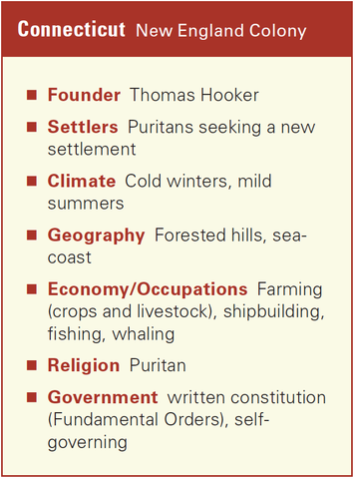
Even in Massachusetts, not all Puritans shared exactly the same ideas. Thomas Hooker was a Puritan clergymanwho lived in New Towne, a fast-growing community next to Boston. Hooker didn’t always agree with the laws and leadership in Massachusetts. When he heard about a fertile valley along a river to the west, he convinced his family and about 100 other people to move there with him. It took Hooker and his followers two weeks to travel to the Connecticut Valley with their animals and belongings. There they established a settlement on the site of an old Dutch fort, where an earlier group of English colonists had settled. They called their new community Hartford. In 1639, Hartford joined with two other settlements to form the colony of Connecticut.

Hooker believed that government should be based on “the free consent of the people,” to whom belongs “the choice of public [officials] by God’s own allowance.” He helped draw up the first written plan of government for any of the colonies. This document was called the Fundamental Orders. The Fundamental Orders guaranteed the right to vote to all men who were members of the Puritan church.
Meanwhile, other Puritans formed a separate colony nearby called New Haven. The Puritans of New Haven agreed to live by the “word of God.” Their laws were stricter than those in Hooker’s Connecticut colony.
Neither of these colonies, however, was legally authorized by the king. Then, in 1662, King Charles II granted a charter for a new Connecticut colony that included New Haven. The charter gave Connecticut colonists more rights than those enjoyed by any other colonists except Rhode Island’s. Legend says that when King James II sent Governor Andros to Hartford 15 years later to take back the colonists’ charter, someone stole it and hid it in the trunk of a huge white oak tree. The “Charter Oak” became a symbol of Connecticut’s freedom.

7. Pennsylvania: A Middle Colony
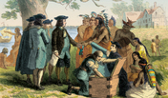
When William Penn asked King Charles II to let him establish a colony in America, the king had two very good reasons for granting Penn’s request. First, he could repay a large debt that he owed to Penn’s father, Admiral Penn. Second, he could get rid of William. The younger Penn had been a thorn in the king’s side for a long time.
William Penn was a member of the Society of Friends, or Quakers. The Quakers believed in a simple lifestyle and in treating all people equally. They refused to bow before the king, fight in wars, or pay taxes to the Church of England.
In 1668, the king had thrown Penn in jail, hoping to stop him from preaching the Quakers’ ideas. To the king’s dismay, Penn continued preaching after his release.
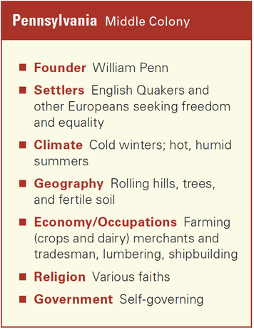
With the Quakers unwelcome in England, Penn wanted to establish a colony in America where they would be safe. In 1681, the king granted Penn a huge area of land between the Puritan colonies of New England and the Anglican colonies of the South. In honor of Penn’s father, the colony was called Pennsylvania.
Penn advertised his colony all over Europe. In his Great Law of 1682, he promised that people of all faiths would be treated equally.
Penn’s appeal attracted settlers from several countries. An early colonist in Pennsylvania marveled at the prosperity and peace in the colony. He wrote, “Poor people (both Men and Women) of all kinds, can here get three times the Wages for their Labour they can in England or Wales . . . Here are no Beggars to be seen . . . Jealousie among Men is here very rare . . . nor are old Maids to be met with; for all commonly Marry before they are Twenty Years of Age.”
Penn named his capital city Philadelphia, which is Greek for “City of Brotherly Love.” From there, he wrote great documents of government that made Pennsylvania the first democracy in America.

6. New York: A Middle Colony
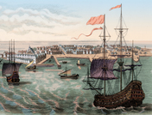
The English took control of the settlement of New Netherland in 1664. The English renamed the colony New York in honor of its new proprietor (owner), James, the Duke of York. The duke gave huge chunks of his colony to two friends, Sir George Carteret and Lord John Berkeley. These men then established the colony of New Jersey to the south of New York.
The duke also awarded large estates along the Hudson River to wealthy Englishmen. The new landowners charged high rents to farmers working their land. This practice created a great difference in wealth between the landowners and their poor tenants. It also discouraged people from settling in New York.
The duke of York expected his colony to be a moneymaking business. As its owner, he appointed people to run the colony. He also issued his own laws and decided what New Yorkers should pay in taxes.
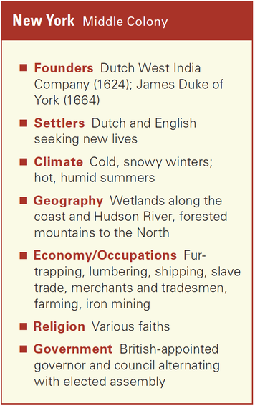
New York’s rich landlords approved of the duke’s approach to governing his colony. But farmers, fishers, and tradespeople did not. They demanded the right to elect an assembly to make laws for New York. The duke refused, saying that elected assemblies had a habit of disturbing the “peace of the government.”
After years of protest, the duke finally allowed New Yorkers to elect an assembly in 1683.This first assembly passed 15 laws. The most important was a charter listing a number of rights that most colonists thought they should have as English citizens. Among them were the right to elect their own lawmakers, the right to trial by jury, and the right to worship as they pleased.
When the duke saw what the assembly had done, he abolished it. New Yorkers did not get a new assembly until, under the leadership of Jacob Leisler (LIES-ler), they rebelled in 1689. Leisler was elected commander in chief of a democratic council that governed until 1691. That year, New York was finally granted the right to elect an assembly with the power to pass laws and set taxes for the colony.

8. Maryland: A Southern Colony
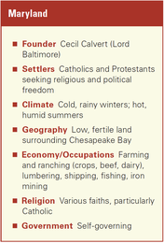
The founding of Maryland was a family enterprise. Sir George Calvert, named Lord Baltimore by King James I, was an English gentleman who became a Roman Catholic. In England, with its official Anglican Church, Catholics were treated harshly. Calvert wanted to start a colony “founded on religious freedom where there would not only be a good life, but also a prosperous one for those bold enough to take the risk.” As a businessman, he also hoped the colony would make his own family more prosperous, or wealthy.
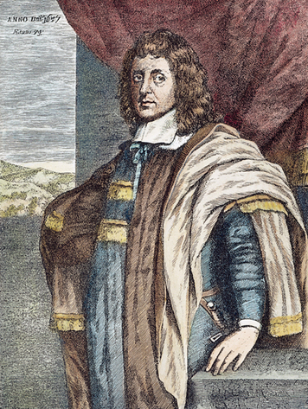
Unfortunately, Calvert died while he was still bargaining with the king. The new king, King Charles I, granted a charter for the colony to Calvert’s son Cecil, the new Lord Baltimore. The charter gave the Calverts complete control of the colony, which was called Maryland.

Armed with these powers, Cecil named his brother Leonard to be governor. To make money from the colony, Cecil needed to attract both Protestant and Catholic settlers. He told Leonard to be “very careful to preserve unity and peace . . . and treat the Protestants with as much mildness and favor as justice will permit.”
Leonard’s expedition arrived in Maryland in 1634. There he and his followers built St. Mary’s City on a high, dry bluff they purchased from American Indians. The following year, Leonard agreed to let Maryland elect an assembly to govern the colony.
As more and more settlers arrived, Leonard could see that Catholics would always be outnumbered in the colony. To protect their rights, in 1649 he helped pass America’s first law guaranteeing religious liberty, the Act Concerning Religion. This law, however, applied only to Christians. Atheists (people who do not believe in the existence of God) and Jews were not included.
Despite the Calverts’ efforts, Protestants and Catholics remained suspicious of one another and waged a tug-of-war in Maryland for more than a century. During this time, the colony’s founding family lost and regained power several times. Still, George Calvert’s dream was fulfilled. Catholics in Maryland worshiped freely and took part in the colony’s government alongside Protestants.

9. Virginia: A Southern Colony
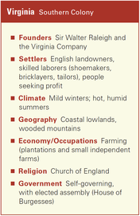
Jamestown, Virginia, was the first successful English settlement in America. After a shaky start, Virginia began to grow and prosper. By 1700, the descendants of those early settlers were wealthy landowners and the most important people in Virginia.
The economy of Virginia was based on tobacco. Tobacco planters needed vast areas of land to be successful. They also needed a large number of workers to grow their crops.
At first, planters tried putting Indians to work. But Indians in this area were not used to farming. Worse, many of them died of diseases they caught from the colonists. The others faded into the forests and disappeared.
Next, tobacco planters tried bringing poor people from England to work their land. In exchange for free passage to Virginia, the workers agreed to become indentured servants for a period of five to seven years. Many men, women, and children came to Virginia as indentured servants. After completing their service, they were given their freedom along with a small plot of land, some clothing, tools, and seeds.
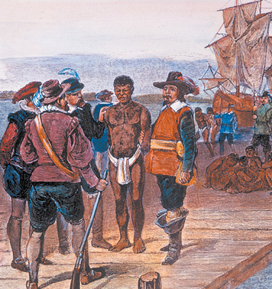
The first Africans brought to Virginia were also treated as indentured servants. At first, they had the same rights and freedoms as white servants. Once their service ended, they could buy land and servants of their own.
Gradually, however, planters turned to slaves to solve their labor problem. Slaves brought from Africa cost twice as much as servants, but they did not leave after a few years.
For the planters, enslaving Africans had other advantages as well. Most Africans were hard workers who were used to farming. And because of their dark skin, it was hard for them to escape from their owners and blend into the rest of the population.
Virginia elected an assembly, called the House of Burgesses, in 1619. In 1661, the House of Burgesses passed a law that made African workers slaves for life. By 1700, Virginia had more than 16,000 enslaved Africans—more than one-fourth of the colony’s population. For Virginia, slavery had become a way of life.

Section 10 - Georgia: A Southern Colony
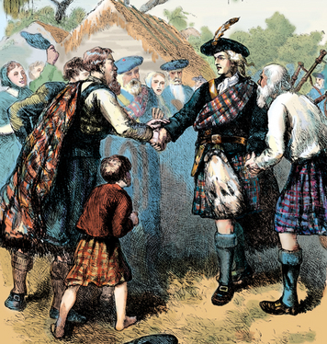
Georgia, the 13th and last colony, was founded by a group of Englishmen whose business plan was based on a grand and noble idea. They wanted to help poor people in England stay out of debtors’ prison. In England, at this time, people who couldn’t pay their bills went to jail. James Oglethorpe inspired wealthy Englishmen to give money to help establish a colony where the poor could build better lives instead of going to jail.
King George II and his government liked this plan because the Georgia colony would help keep the Spanish from moving north out of Florida. Georgia would stand between Spanish Florida and the rest of the British colonies to the north.
The Englishmen’s plan depended on getting the cooperation of settlers. But there weren’t many poor debtors who wanted to start new lives in the wilderness of North America.Some thought prison would be a safer place.
Instead of an army of poor people, the colonists who went with Oglethorpe to Georgia in 1732 were adventurers much like the settlers in the other colonies. In addition, many Protestants, Catholics, and Jews came to Georgia in search of religious freedom.
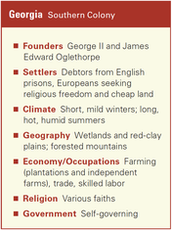
As many had feared, life was not easy in Georgia. The Spaniards in Florida wanted to control Georgia, and they continually attacked the new settlements. The Georgians fought them off without any help from the other British colonies. To make matters worse, Oglethorpe had specific ideas about how the colonists should live. He established laws against drinking alcohol and owning slaves. He thought the settlers should live on small farms and learn to farm their land themselves.
The settlers weren’t about to go along. They wanted to farm large plantations and own slaves like the wealthy planters in neighboring colonies. They disliked some of Oglethorpe’s other rules as well.
After 12 years of governing the colony, Oglethorpe returned to England. In 1752, the people of Georgia elected an assembly.

